In an ancient city Jimbo there lived a temple i.e Majolin. The temple had a protector by the name jehu. The temple had a secret a jade by the name Pigroma. It possessed super-natural powers that could cure all diseases in the world. Many fighters with different interest from all over the world q showed up for a competition to try and get the pigroma for their own. The winner will have to face Jehu after killings all other fighters.

H
[ZenodCompanies]
[Naivasha,Nakuru]
[0100424560]
[gilgadzenod47@gmail.com]
[josephwachira965@gmail.com]


P
[Pigroma Hunt]
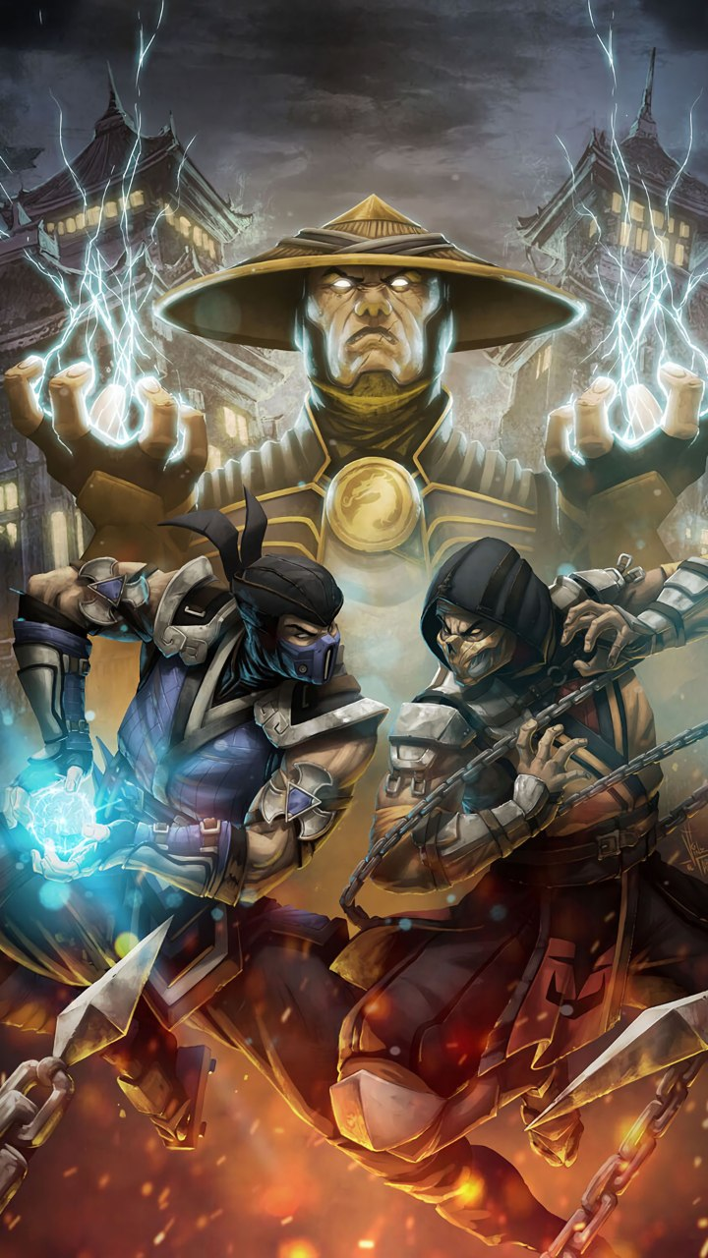

Fig 1 Cover photo

Pigroma hunt Table of Contents
3
Introduction 1
2.0 Characters in Pigroma hunt 2
1. Mirror 2
2. Ray 2
3. Teen Tiger 2
4. Thunder 2
5. Ghost 2
6. Voices 2
7. Earth 2
8. Steel 2
9. Hech 2 O 2
10. Fire 2
11. Knight 2
12. Genny 2
13. Mogzy 2
14. Gilzam 3
15. Krystal 3
3.0 Characters capabilities 3
i. Mirror 3
ii. Rayz 3
iii. Teen Tiger 3
iv. Thunder 3
v. Snowy 3
vi. Ghost 3
vii. Echo 3
viii. Earth 4
ix. Steel 4
x. Hech 2 O 4
xi. Fire 4
xii. Knight 4
xiii. Genny 4
xiv. Mogzy 4
xv. Gilzam 4
xvi. Crystal 5
4.0 Characters Origin of Powers and desires for the Pigroma 6
1. Mirror 6
2. Rayz 7
3. Teen Tiger 8
4. Thunder 9
Snowy 11
6. Ghost 12
Voices 13
8. EARTH 14
Hech20 15
10. Fire 17
11. Knight 19
12. Genny 21
13. Mogzy 22
5.0 Pigroma capabilities 23
6.0 Game Controls 24

In an ancient city Jimbo there lived a temple i.e Majolin. The temple had a protector by the name jehu. The temple had a secret a jade by the name Pigroma. It possessed super-natural powers that could cure all diseases in the world. Many fighters with different interest from all over the world q showed up for a competition to try and get the pigroma for their own. The winner will have to face Jehu after killings all other fighters.

Characters in Pigroma hunt

Mirror

Ray

Teen Tiger

Thunder

Ghost

Voices

Earth

Steel

Hech 2 O

Fire

Knight

Genny

Mogzy

Gilzam

Krystal

Characters capabilities

Mirror
Can easily copy the capabilities of anybody and almost immortal.

Rayz
Very radiant and strikes on high radiation try and find a wit out of him.

Teen Tiger
A two in one and capable of a combat.

Thunder
Can produce lightning and fight any opponent.

Snowy
Can produces icy wind and hence dangerous.

Ghost
Ghost the devil’s daughter can change in to a ghost into a ghost and strike using very poisonous needles.

Echo
Produces many voices(echo) and uses this advantage to strike his opponent.

Earth
Earth the galaxy descendant has the power over earthy materials and hence advantageous in a combat.

Steel
As his name goes steel can attract any metallic equipment around him use him to get weapons from metals.

Hech 2 O
H₂o has the ability of using hydrogen and oxygen and produce water and in turn use it for a combat.

Fire
As his name goes fire can easily produce flames from his arms and strike it to his opponent.

Knight
Knight is a well trained Ex-soldier and fit for a combat.

Genny
He is a famous business man out there and well equipped with weapons.

Mogzy
He is a hunter in the deep thickets of Jimbo forest.

Gilzam
Gilzam is a former magician and use his wits to attack his opponents very fit for a combat.

Crystal
He is capable for attracting glasses and throw the at his opponent hence toxic I mean super toxic.

Characters Origin of Powers and desires for the Pigroma
- 

Fig 2 Mirror photo
Mirror was among the few members of the Knine Family. The family made mirrors using their hereditary powers in the Jimbo outskirts and stuff. The family was chased away by the communists in the village. The K nine's used their magic and open a portal and run away. Coincidentally Mirror was left in his room asleep during the run away. On his morning arise he found no one in the environs and has survived all along alone in the wilderness. Mirror has all along heard about the pigroma and desires to confiscate it with whatever it takes and open the way to his fellow family. Help him fight and win the battle and he will be cool when he meets his fellow fam out there.
- 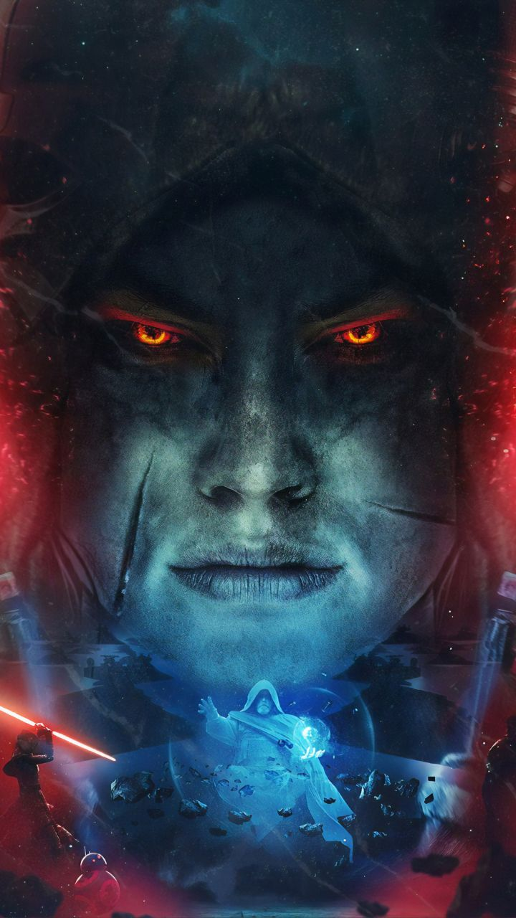

Fig 3 Rayz Photo
Zeacii commonly known as zeacii was among the zenod mad clan. The clan secured the galaxy I mean like the sun, moon and stars.They were responsible for changing the day and night. He is the final descendant in the clan. The fellow clan members were attacked by aliens and coincidentally only him was saved from the attack by being cast into the Jimbo environs. The Pigroma has the ability to also raise the dead. Rayz has all along been so lonely in the village and decides to join the battle to try his luck and see if he is going to win the battle. Try and help him to get the pigroma and get his family back alive again.

Teen Tiger

Teen tiger the two in one creature I.e a human and a tiger is a son of kuntah family. They lived near a forest at the outskirts of Jimbo city. One day Teen tiger did on his contrary of his father’s instructions on going into the forest as the forest entailed many villain creatures from snakes to bears just to mention. On his visit out there he was attacked by a tiger that fiercely cut deep in between his flesh. His father came to his rescue and luckily shot the tiger. Onwards after the attack teen started to show out some funny characteristics during his lone stay at home. One day as his father was still in grudge of his sons behavior some day ago, he went and got very drunk, he came and decided to show his son how to follow instructions the hard way .Teen unknowingly changed into a gigantic tiger and fiercely and mercilessly tore his father into pieces. His new intervention and ability made him run away into the deep forests. News spread all over the city about his new deed the villagers were zooted to search him all over in the pits, twigs, shrubs and all over the forest to merk him, out of the earth’s atmosphere. Teen tiger has heard the treasure hunt of the great Pigroma. He has decided to get into the hunt and get the pigroma and change his condition and also revert his action of merking his father. Help him to get the pigroma and change his condition.

Thunder

Fig 5 Thunder photo
Kryptonite comes from the Tyla family. He worked in a power plant that served the whole Jimbo city. One day as he was reconfirming the validity of the machinery at work lightning stroke the power plant and it was all brought down into ashes. Many were killed on the same spot and only a few survived from the trauma and among them was Kryptonite and other few employees though very burned up on his face beyond recognition Krypt had a new intervention in his body beams of sparkling electrons came from his body and he could strike it at anyone close to his when worried or tempered. One of the fire fighters so the glowing creature and screamed out for help. At once he stroke him with a single blow to death

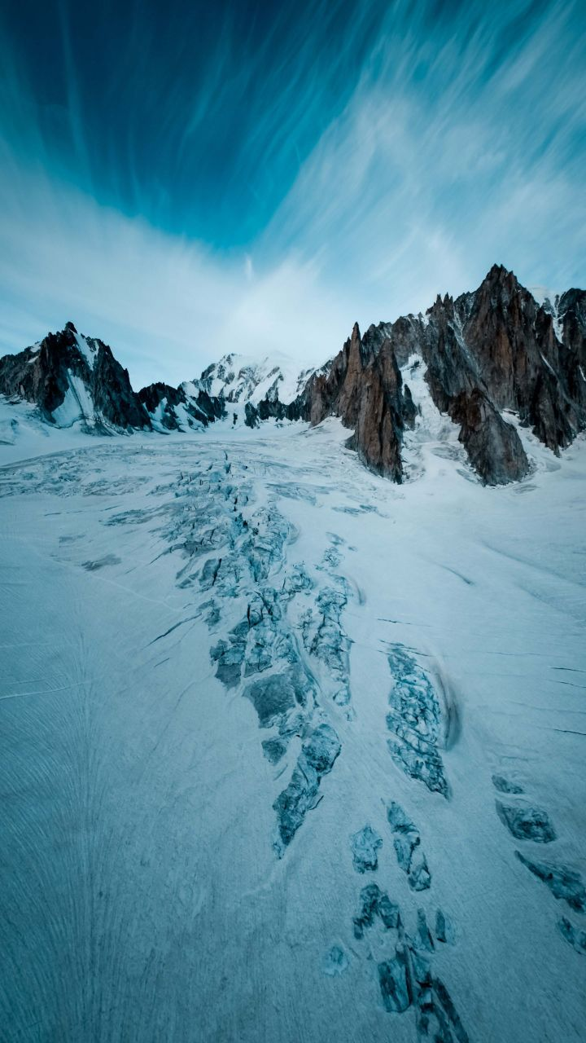

Fig 6 Snowy’s Photo
Snowy was a famous ice cream vendor in Snow-land,Jimbo. She was the owner of the icing company countrywide and her ice cream business was a great investment . Her business nourished so much and she achieved most of her dreams in her lifetime.But one day as she was travelling to work using her private jet his pilot tremendously felt asleep and the plane got its control by itself. It was in the early days so the plane did not have an auto piloting feature. The plane crushed into the icing environs of snow- land many including the pilot lost their lives in the plane crush.Her body got buried in the ice and she passed out few moments later she got her consciousness and a new intervention befall-ed her body . She dressed on white iced garments probably like those in Disney toons … ice came out of her both hands every time she stretched them out. She had to run away from the scene or else she could stand the blame of the merking …On her run away she eavesdropped some people speaking about the pigroma and its capabilities. She can do whatever it takes to get the Pigroma and change her condition and that would be her gratitude. Help her get the Pigroma.

Ghost

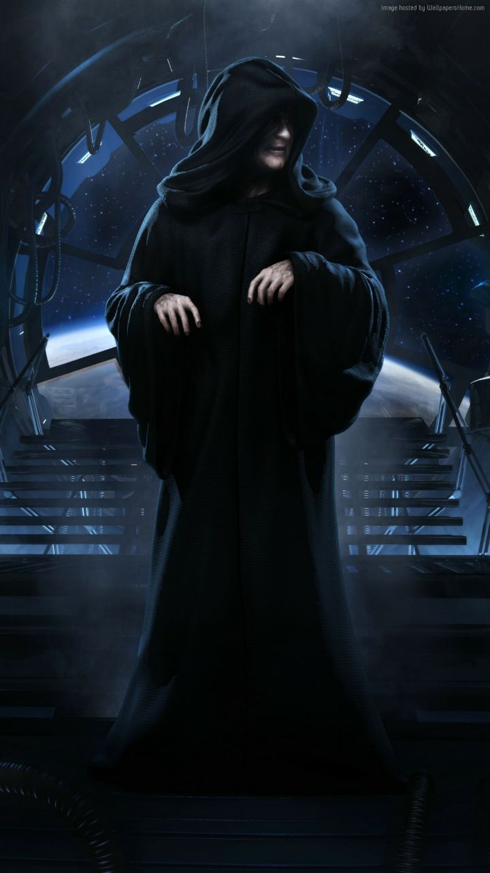
Fig 7 Ghost’s photo

Thenom Bikita was a daughter to one of the priests in Jimbo City. His father a priest in the world revelation church. He had the ability to cast out demons out of his disciples and anyone else. Though during his mission undertake he came across a new demon intervention the Thenom Bikita probably one of Satan's descendants. As he tried to cast it out it accidentally possessed his own daughter Gilly. The demon acquired more power by manipulating and possessing her. The demon used the new advantage and killed the priest. Gilly couldn’t stand the occurrence and blame for the villa Jimboists . She had to run away as fast as she could. She heard about the Pigroma in the temple protected by Jehu and she decided to tryna get her luck out there. Help her get the jade and cast out the ‘Thenom Bikita’ and revert the killing of his own father and continue his preaching of the ministry to the localists of Jimbo.
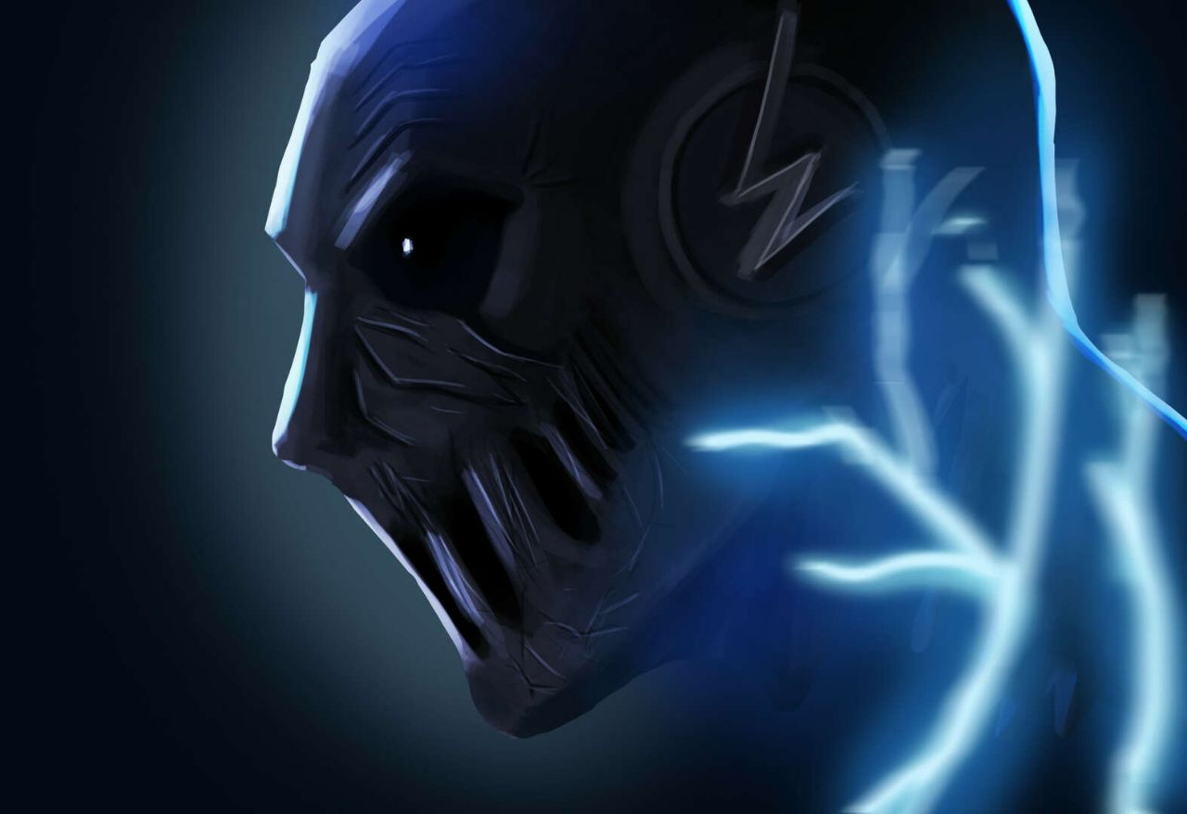

Fig 8 Voices’s photo
VDJ Echo was a famous disc jockey in the fan city,Jimbo. His glory spread all over the in and out skirts of Jimbo Environs. During one of his concerts prepared in City’s CBD, he had the whole pressure and tension for he wanted it to be a banger than before. He prepared all night long and of course recorded it on his PC. The music Headphones exposed him to ultra-humanistic Radiation that made him hear and say voices with the echo effect the new ability made him a worried man for the whole new upcoming concert would become a mess, shame and a disgrace to his lifetime career but what could he do? The D-day morning arose with its charming and piercing sun rays rose upon his face what else could he do other than retest whether his recording was still valid and kicking. The test made him be assured that his concert was a true failure he was forced to write in his blog and social media platform than he was unable to go for the concert. Despite all his professionalism and capabilities he couldn’t just do. The shaming and haunting comments from his bone-flesh fans tormented him and he was forced to run away to the bushes and he has joined the hunt and can do whatever it takes just to win the pigroma and go beat the BANGER out there and make millions of money. Help him get his dream achieved.

- 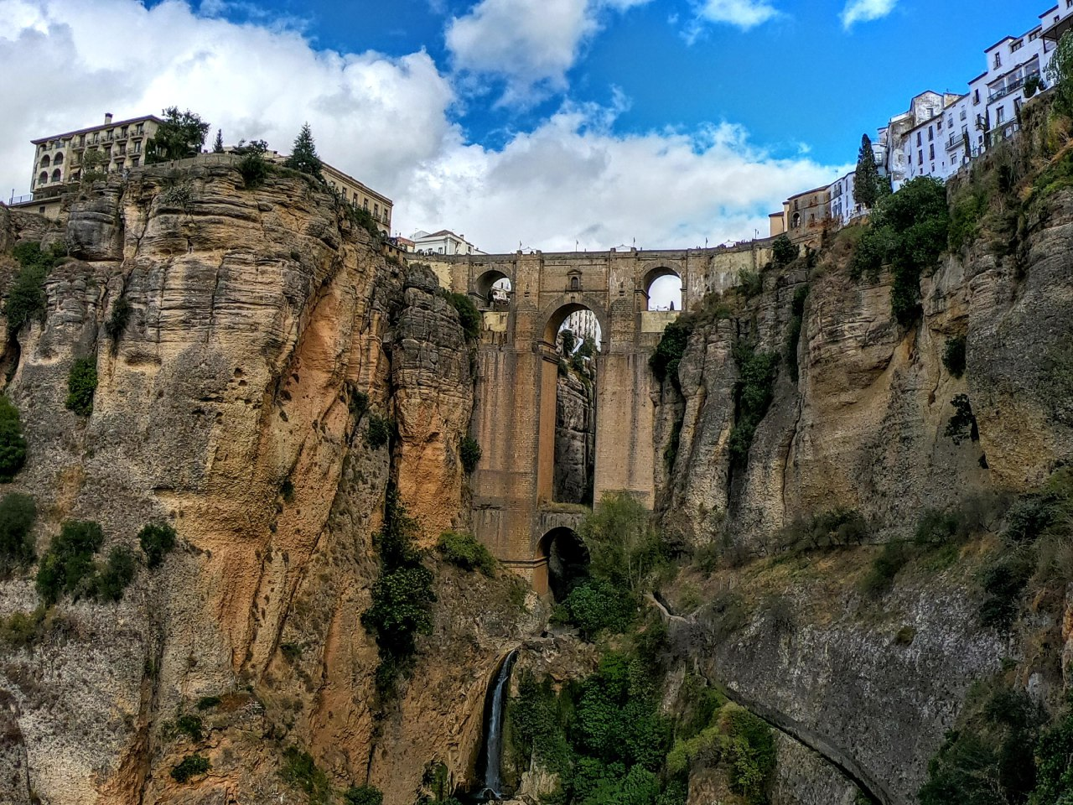

Fig 9 Earth’s photo
Thilla was a palaeontologist in the deep pyramids of the pharaohs.During his lifetime career of the mummies discovery and study, he discovered a mummy probably from the pharaohs and made the decision to pick it up and put it on his neck probably to study it later. But wonders befallen him and every time he pointed at anything massive amounts of dusty sand covered it he couldn’t understand how the occurrence happened until when he pointed at his colleague her only beloved wife and she turned into dust and faded away. What had befallen him this time. In a horrified atmosphere he looked at the dusts-her formed wife and started to cry out loud in pain.He then discovered that he had become an Earth- bender. Though sad this was one of his greatest discoveries in his career but he was to blame of her own wife murder. He collected the dusty soil and put it I a bag and of course to take it home. No one knew what happened in the caves and decided to say that her wife was overlay-ed by one of the caves and he decided to carry the dust in her wife’s memory. Thilla decided to take her wife’s dust in his room and investigate on how to revert the process. During his investigation he discovered about the medallion Pigroma and he decided to hunt for it. He can do whatever it takes just to make sure he gets the Pigroma. Help him get the pigroma.
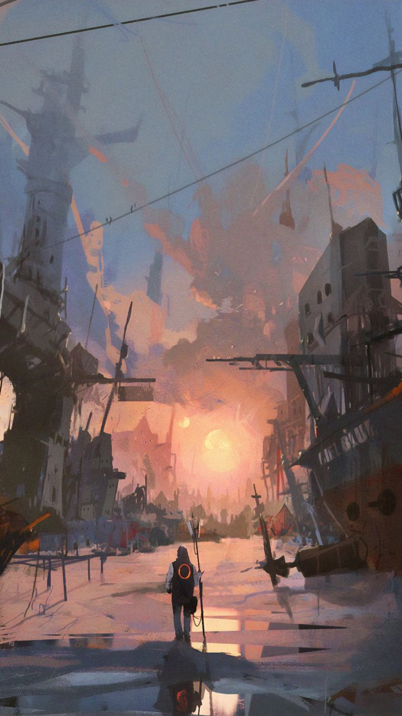

Fig 10 H20’s Photo
Jawsay was among the few privileged to border the hdro-sea in Jimbo. He worked as a professional fisherman as a method of living and this made him money though little. He was also among the many less privileged to have money. Though he has always dreamed to have money and at least open a children home to… and other people. His financial condition made him lack to sufficiently offer favourable conditions for survival such as good education and stuff.But surprisingly her wife and kids lived in peace and satisfaction from the lil provision-they loved each other. One day during his usual business - Fishing he brought out a strange glowing medallion from the deep sea. He didn’t know what it was and so he put it on his neck. No sooner had he put it on his neck than he melted. He couldn’t take it out-or how do you expect water to do that? In shame and shock he decided to jump into the sea and at least save his son’s live -I mean like the boat could sink.He couldn’t sink nor float he dissolved totally and his clothes stripped itself off.His son couldn’t stand the whole occurrence and he passed out. Jawsay ride the boat to the docks and decided to run away although he couldn’t move he felt very heavy - he was water-and water cannot get out of water he had to stay in the water don’t ask me of what he ate. When his son rose he could only see a strange creature standing in the water’s resembling a human. He rushed very fast at home and explained all that happened. Her wife didn’t believed what was said unless his son substantiated what he said. Her son took her to the spot and Jawsay appeared as liquefied human though horrified she had to find out what could revert the process and have his husband back. During her investigation she found out of the great treasure Pigroma. She informed his husband about the Jade. Once he had the jade he could turn back into his normal form. He has decided to take part in the treasure hunt and fix up…
- 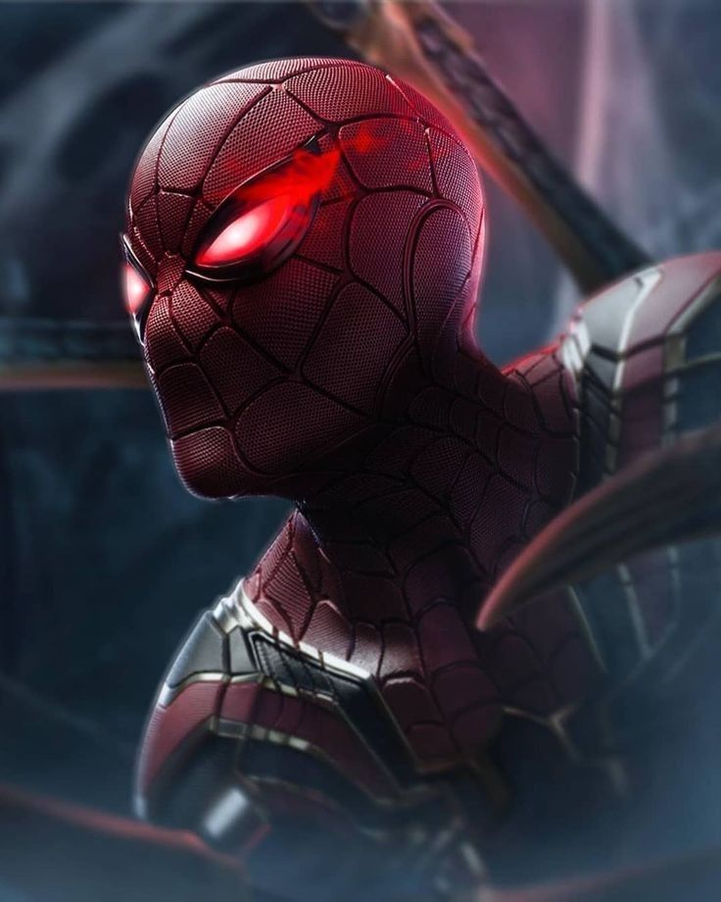

Fig 11 Fire’s Photo
Lumina moto was a worker in a gas generation plant. HE was among the few to have a permanent job in the premises and he took his work so serious that he got a promotion. His lifetime career was nourishing that he worked o the generation point .He could work for long hours in the pits down there and come out only once in a week this made him take massive amounts of the fumes. One day one of his colleague a cigar smoker decided to burn his chest-smoke. As soon as he stroke his lighter did flames and explosions turn up at the plant Everything burnt up. Fire lighters were prohibited in the area but Lumina’s colleague got his mind better and broke the rules. The fire also decided to teach him a lesson too-he was burnt to death. Lumina's long exposure to the gas made him only his clothes burnt up- he survived. A great and unusual intervention had befallen him he was all over burning but couldn’t get finished-was he immortal? Nah! He was fire and couldn’t get burnt. He even tried to pour himself water but he couldn’t go off_I think he could boil a whole ocean by himself. But could he stand the blame of the plant burning. He had to of course run away and know how to revert the occurrence. No time was available for wastage he run away though burning_If anyone met him would say s/he met the so called Satan. Unfortunately he went to the city calling for help but no one could help ‘Satan’ everyone run away. He decided to make use of his advantage and got inside a swimming pool. The pool boiled up and Lumina was still burning. People surrounded the place taking pictures maybe to make more views on the occurrence. Alright,Lumina's life was in danger and his survival chances went narrower and narrower although a celebrity. He decided to run away and get the so long told Pigroma in the Majolin temple. Help him get the pigroma and clean-up his name.

Knight
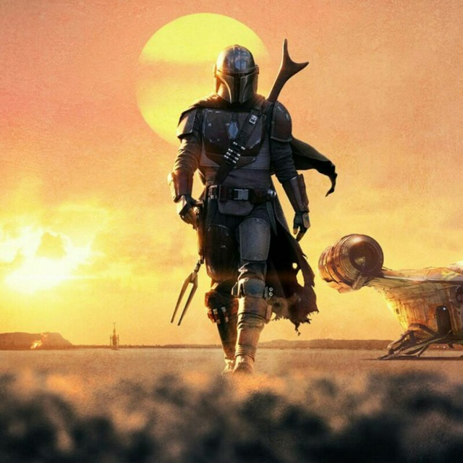
Knight commonly known as Sergeant Debru is a former Ex-soldier.He considers his career a failure when he was part of the soldiers in a war against the com-monists of Afghanistan. He recalls with great nostalgia the events when his very close friend Alto got shot. Alto’s life could get spared if Knight did not hesitate to kill a young boy - suocidebomber.It was during the great war in Afghanistan. Knight was sent together with his colleague Alto. Knight was a sniper by profession and Alto was his spotter. Knight told his spotter to go to a nearby building which was in a well raised point for view. Knight was to watch Alto’s back since the streets were ain’t safe. For a soldier like him. As he was moving a young Arabic kid showed up and started walking towards Alto. Knight saw the kid but gave no thought of the kid being among the villas in the locality- Jihad terrorists. The kid moved closer to Alto and immediately he was close to Alto he hurriedly put his arm I his garments and he blew up. Not alone but together with Alto. Knight shouted up in anger and despair. He raised the alarm of his presence. The terrorists attacked him really bad and killed almost got himself merked out. The events of the whole predicament made him to quit as soldier and lived out with guilt of his partner’s death. In his stay out there he heard of the existence of the Pigroma-maybe he could go back in time and fix up, make a wish and get his partner back alive and get himself a way out of the blame. He has shown up up in the battle and wishes you to help him achieve his long time desires
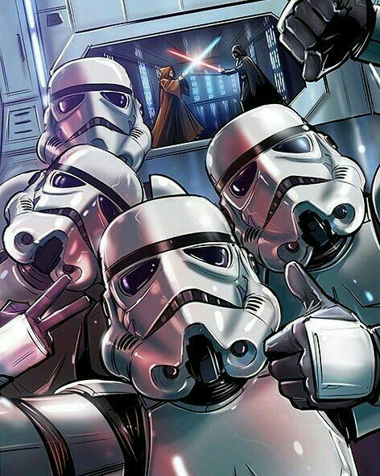Genny is a famous businessman-a jewellery dealer. He has set-up a big shop in Jimbo city. It is well paying but the normal desires of man he wishes to get more and more coins out of the business.He has heard the rumour of the Pigroma He sees the Pigroma a great treasure to auction and also to use maybe make a wish for his business to nourish and also maybe give him good luck. But I don’t think so because of his fast thing happenings desires. He has decided to get a group of commandos to undertake the mission and tryna grab Pigroma BOA. Help the group to succeed in their mission.

Mogzy
As I stated earlier Mogzy is a famous hunter in the deep forest of Jimbo. His business in the thickets is really relishing and a great meagre is going to face him if things are not fixed up as quick as possible. He wishes to tryna get things right by taking part in the Pigroma Hunt and believes he being a hunter this sounds like a piece if cake and he has decided to gather any weapons necessary and tryna merk out anyone who comes on his way. Mogzy is not only a plain hunter but also an Ex-soldier in the US army. He has also gathered his fellow retired soldiers and wishes to get the pigroma to Make a wish of money and cash up himself help him meet his desires by grabbing the Pigroma BOA

5.0 Pigroma capabilities
- Revert any occurrence
- Move back in time
- Cure all diseases
- Grant any wish said
- Cast out demons
- Cast out any plague befallen anyone
- Used to move in all planets across the galaxy.
- Arise the dead
- Can make one really fight
- Can make one to fly
- Can give one good luck I mean like ‘win a lottery’

6.0 Game Controls
Jump
Move Left or Right
P
Pick-up an Object
c
Make an object a weapon
Move Up and Down
Target
Strike
Direction arrows

